1. Build with cuDnn

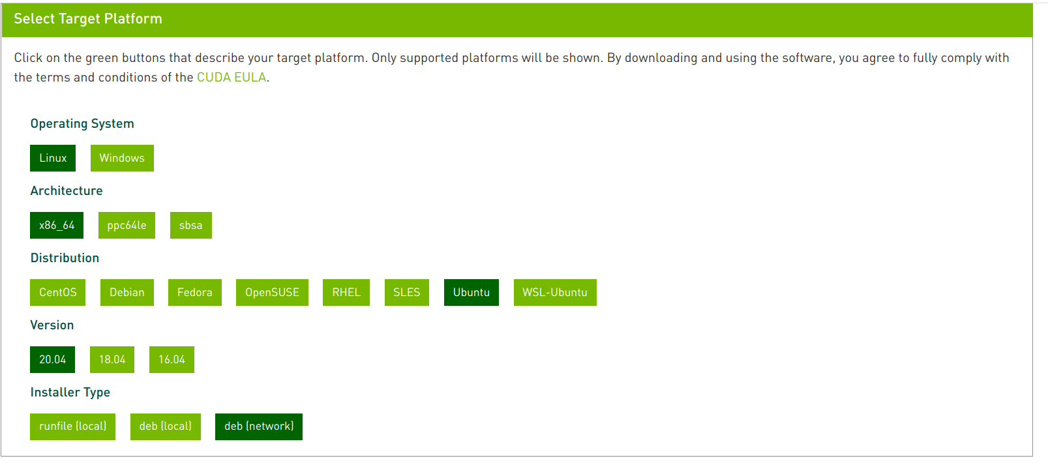

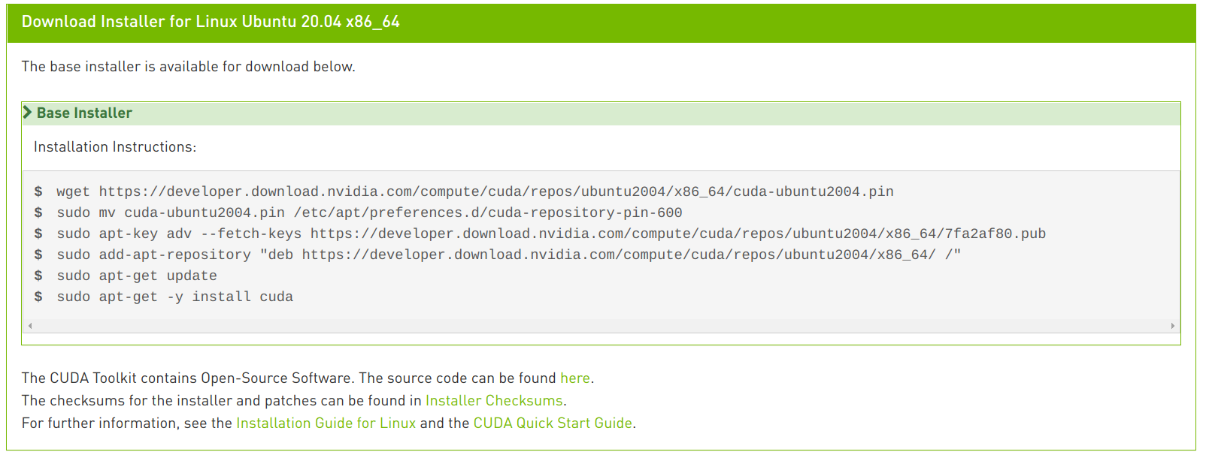

wget <https://developer.download.nvidia.com/compute/cuda/repos/ubuntu2004/x86_64/cuda-ubuntu2004.pin>

sudo mv cuda-ubuntu2004.pin /etc/apt/preferences.d/cuda-repository-pin-600

sudo apt-key adv --fetch-keys <https://developer.download.nvidia.com/compute/cuda/repos/ubuntu2004/x86_64/7fa2af80.pub>

sudo add-apt-repository "deb https://developer.download.nvidia.com/compute/cuda/repos/ubuntu2004/x86_64/ /"sudo apt-get updatesudo apt-get -y install cuda

### **[Export CUDA path](https://gist.github.com/matheustguimaraes/43e0b65aa534db4df2918f835b9b361d" \l "export-cuda-path)**

export LD_LIBRARY_PATH=/usr/local/cuda-11.2/lib64:$LD_LIBRARY_PATH

export PATH=/usr/local/cuda-11.2/bin:$PATH

Download [cudnn-11.2-linux-x64-v8.1.0.77.tgz](https://developer.download.nvidia.com/compute/machine-learning/cudnn/secure/8.1.0.77/11.2_20210127/cudnn-11.2-linux-x64-v8.1.0.77.tgz?XL8hEAPMfdIqkElFrpEXsliq1V7bwG_uD4dR1cEYyiGwCK21iWmb4lQ5EYyeGsimLOSVxQqA8opl_kHVVCfW89cvvMZoL4IFab_GnKuZvaySqMHeE7gvQFxdUX7kRjcUcaId_FLELk5nJ-9i97lA9c3zyNIANHGOo5XrLPugx3TKvlEVLtr2sTflnlQhCMvr-0VzinyRWo6yC2JNJK4)

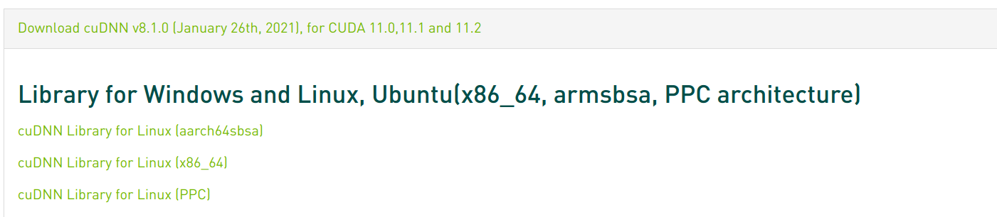

Copy the following files into the CUDA Toolkit directory.

$ sudo cp cuda/include/cudnn*.h /usr/local/cuda-11.2/include

$ sudo cp -P cuda/lib64/libcudnn* /usr/local/cuda-11.2/lib64

$ sudo chmod a+r /usr/local/cuda-11.2/include/cudnn*.h /usr/local/cuda-11.2/lib64/libcudnn*

IN opencv CMAKE config:

First change compiler to CMAKE_C_COMPILER and CMAKE_CXX_COMPILER to gcc-8 and g++8, then make your changes

CUDNN_INCLUDE_DIR:FILEPATH=D:/.../cudnn-7.5.6/include

CUDNN_LIBRARY:FILEPATH=D:/.../cudnn-7.5.6/lib/cudnn.lib

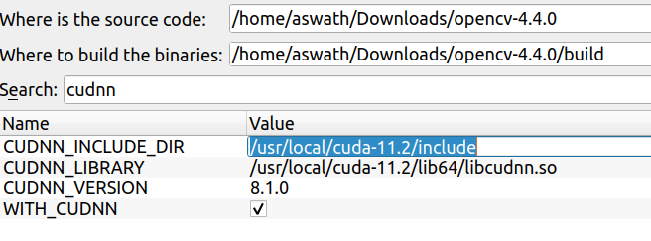

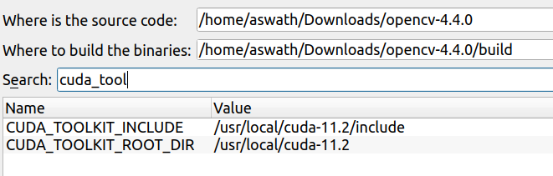

<command-line>: warning: ISO C++11 requires whitespace after the macro name

<command-line>: warning: ISO C++11 requires whitespace after the macro name

/home/aswath/Downloads/opencv_contrib-4.4.0/modules/hfs/src/cuda/../or_utils/or_memory_block.hpp: In instantiation of ‘void cv::hfs::orutils::MemoryBlock<T>::clear(unsigned char) [with T = cv::hfs::orutils::Vector4<unsigned char>]’:

/home/aswath/Downloads/opencv_contrib-4.4.0/modules/hfs/src/cuda/../or_utils/or_memory_block.hpp:42:1: required from ‘cv::hfs::orutils::MemoryBlock<T>::MemoryBlock(size_t) [with T = cv::hfs::orutils::Vector4<unsigned char>; size_t = long unsigned int]’

/home/aswath/Downloads/opencv_contrib-4.4.0/modules/hfs/src/cuda/../or_utils/or_image.hpp:18:84: required from ‘cv::hfs::orutils::Image<T>::Image(cv::hfs::orutils::Vector2<int>) [with T = cv::hfs::orutils::Vector4<unsigned char>]’

/home/aswath/Downloads/opencv_contrib-4.4.0/modules/hfs/src/cuda/gslic_seg_engine_gpu.cu:43:115: required from here

/home/aswath/Downloads/opencv_contrib-4.4.0/modules/hfs/src/cuda/../or_utils/or_memory_block.hpp:47:7: warning: ‘void* memset(void*, int, size_t)’ writing to an object of non-trivial type ‘class cv::hfs::orutils::Vector4<unsigned char>’; use assignment instead [-Wclass-memaccess]

memset(data_cpu, defaultValue, dataSize * sizeof(T));

^ ~~~~~~~~~~~~~~~~~~~~~~~~~~~~~~~~~~~~~~~~~~~~~~

/home/aswath/Downloads/opencv_contrib-4.4.0/modules/hfs/src/cuda/../or_utils/or_vector.hpp:63:26: note: ‘class cv::hfs::orutils::Vector4<unsigned char>’ declared here

template <class T> class Vector4 : public Vector4_ < T >

^~~~~~~

/home/aswath/Downloads/opencv_contrib-4.4.0/modules/hfs/src/cuda/../or_utils/or_memory_block.hpp: In instantiation of ‘void cv::hfs::orutils::MemoryBlock<T>::clear(unsigned char) [with T = cv::hfs::orutils::Vector4<float>]’:

/home/aswath/Downloads/opencv_contrib-4.4.0/modules/hfs/src/cuda/../or_utils/or_memory_block.hpp:42:1: required from ‘cv::hfs::orutils::MemoryBlock<T>::MemoryBlock(size_t) [with T = cv::hfs::orutils::Vector4<float>; size_t = long unsigned int]’

/home/aswath/Downloads/opencv_contrib-4.4.0/modules/hfs/src/cuda/../or_utils/or_image.hpp:18:84: required from ‘cv::hfs::orutils::Image<T>::Image(cv::hfs::orutils::Vector2<int>) [with T = cv::hfs::orutils::Vector4<float>]’

/home/aswath/Downloads/opencv_contrib-4.4.0/modules/hfs/src/cuda/gslic_seg_engine_gpu.cu:44:104: required from here

/home/aswath/Downloads/opencv_contrib-4.4.0/modules/hfs/src/cuda/../or_utils/or_memory_block.hpp:47:7: warning: ‘void* memset(void*, int, size_t)’ writing to an object of non-trivial type ‘class cv::hfs::orutils::Vector4<float>’; use assignment instead [-Wclass-memaccess]

memset(data_cpu, defaultValue, dataSize * sizeof(T));

^ ~~~~~~~~~~~~~~~~~~~~~~~~~~~~~~~~~~~~~~~~~~~~~~

/home/aswath/Downloads/opencv_contrib-4.4.0/modules/hfs/src/cuda/../or_utils/or_vector.hpp:63:26: note: ‘class cv::hfs::orutils::Vector4<float>’ declared here

template <class T> class Vector4 : public Vector4_ < T >

^~~~~~~

/home/aswath/Downloads/opencv_contrib-4.4.0/modules/hfs/src/cuda/../or_utils/or_memory_block.hpp: In instantiation of ‘void cv::hfs::orutils::MemoryBlock<T>::clear(unsigned char) [with T = cv::hfs::slic::gSpixelInfo]’:

/home/aswath/Downloads/opencv_contrib-4.4.0/modules/hfs/src/cuda/../or_utils/or_memory_block.hpp:42:1: required from ‘cv::hfs::orutils::MemoryBlock<T>::MemoryBlock(size_t) [with T = cv::hfs::slic::gSpixelInfo; size_t = long unsigned int]’

/home/aswath/Downloads/opencv_contrib-4.4.0/modules/hfs/src/cuda/../or_utils/or_image.hpp:18:84: required from ‘cv::hfs::orutils::Image<T>::Image(cv::hfs::orutils::Vector2<int>) [with T = cv::hfs::slic::gSpixelInfo]’

/home/aswath/Downloads/opencv_contrib-4.4.0/modules/hfs/src/cuda/gslic_seg_engine_gpu.cu:54:80: required from here

/home/aswath/Downloads/opencv_contrib-4.4.0/modules/hfs/src/cuda/../or_utils/or_memory_block.hpp:47:7: warning: ‘void* memset(void*, int, size_t)’ writing to an object of non-trivial type ‘struct cv::hfs::slic::gSpixelInfo’; use assignment instead [-Wclass-memaccess]

memset(data_cpu, defaultValue, dataSize * sizeof(T));

^ ~~~~~~~~~~~~~~~~~~~~~~~~~~~~~~~~~~~~~~~~~~~~~~

/home/aswath/Downloads/opencv_contrib-4.4.0/modules/hfs/src/cuda/../slic/slic.hpp:67:8: note: ‘struct cv::hfs::slic::gSpixelInfo’ declared here

struct gSpixelInfo

^~~~~~~~~~~

<command-line>: warning: ISO C++11 requires whitespace after the macro name

33%] Building CXX object modules/world/CMakeFiles/opencv_world.dir/home/aswath/Downloads/opencv_contrib-4.4.0/modules/hfs/src/merge/merge.cpp.o

[ 33%] Building CXX object modules/world/CMakeFiles/opencv_world.dir/home/aswath/Downloads/opencv_contrib-4.4.0/modules/hfs/src/slic/gslic_engine.cpp.o

In file included from **/home/aswath/Downloads/opencv_contrib-4.4.0/modules/hfs/src/or_utils/or_image.hpp:9**,

from **/home/aswath/Downloads/opencv_contrib-4.4.0/modules/hfs/src/or_utils/or_types.hpp:9**,

from **/home/aswath/Downloads/opencv_contrib-4.4.0/modules/hfs/src/precomp.hpp:12**,

from **/home/aswath/Downloads/opencv_contrib-4.4.0/modules/hfs/src/hfs_core.cpp:5**:

/home/aswath/Downloads/opencv_contrib-4.4.0/modules/hfs/src/or_utils/or_memory_block.hpp: In instantiation of ‘**void cv::hfs::orutils::MemoryBlock<T>::clear(unsigned char) [with T = cv::hfs::orutils::Vector4<unsigned char>]**’:

**/home/aswath/Downloads/opencv_contrib-4.4.0/modules/hfs/src/or_utils/or_memory_block.hpp:42:9:** required from ‘**cv::hfs::orutils::MemoryBlock<T>::MemoryBlock(size_t) [with T = cv::hfs::orutils::Vector4<unsigned char>; size_t = long unsigned int]**’

**/home/aswath/Downloads/opencv_contrib-4.4.0/modules/hfs/src/or_utils/or_image.hpp:19:49:** required from ‘**cv::hfs::orutils::Image<T>::Image(cv::hfs::orutils::Vector2<int>) [with T = cv::hfs::orutils::Vector4<unsigned char>]**’

**/home/aswath/Downloads/opencv_contrib-4.4.0/modules/hfs/src/hfs_core.cpp:66:58:** required from here

**/home/aswath/Downloads/opencv_contrib-4.4.0/modules/hfs/src/or_utils/or_memory_block.hpp:47:15:** **warning:** ‘**void* memset(void*, int, size_t)**’ writing to an object of non-trivial type ‘**class cv::hfs::orutils::Vector4<unsigned char>**’; use assignment instead [**-Wclass-memaccess**]

**memset(data_cpu, defaultValue, dataSize * sizeof(T))**;

**~~~~~~^~~~~~~~~~~~~~~~~~~~~~~~~~~~~~~~~~~~~~~~~~~~~~**

In file included from **/home/aswath/Downloads/opencv_contrib-4.4.0/modules/hfs/src/or_utils/or_types.hpp:8**,

from **/home/aswath/Downloads/opencv_contrib-4.4.0/modules/hfs/src/precomp.hpp:12**,

from **/home/aswath/Downloads/opencv_contrib-4.4.0/modules/hfs/src/hfs_core.cpp:5**:

**/home/aswath/Downloads/opencv_contrib-4.4.0/modules/hfs/src/or_utils/or_vector.hpp:63:26:** **note:** ‘**class cv::hfs::orutils::Vector4<unsigned char>**’ declared here

template <class T> class **Vector4** : public Vector4_ < T >

**^~~~~~~**

[ 33%] Building CXX object modules/world/CMakeFiles/opencv_world.dir/home/aswath/Downloads/opencv_contrib-4.4.0/modules/hfs/src/slic/slic.cpp.o

[ 33%] Building CXX object modules

$ sudo ldconfig

**After installing:**

**if you get errors like this:** undefined reference to `cv::cuda::threshold(cv::_InputArray const&, cv::_OutputArray const&, double, double, int, cv::cuda::Stream&)'

Its either because you haven’t defined the header files or because of previous build configurations, solution below to refresh your build configuration.

* Always refresh your workspace,
* clean any previous build and build configuration files and
* restart your workspace.